1. Consider the following figure-

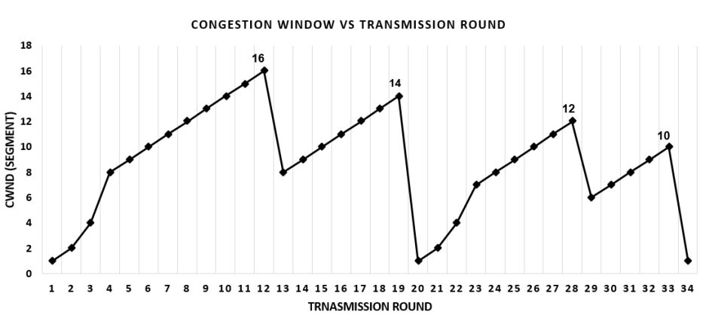

* 1. Why do you think after the 4th transmission round, the congestion window increases linearly rather than exponentially? Describe with appropriate reason.
  2. Find the ranges of rounds where the Congestion Avoidance phase occurs Mention the ranges separately.

1. Consider a three-node topology and the link costs are c(p, q) = 4, c(q, r) = 3, c(r, p) = 9. Assume that each node initially knows the costs to each of its neighbors. Compute the distance table after the initialization step and calculate the step-by-step distance table entries of each node using the distance vector routing algorithm for the first 3 timestamps only. Suppose that the link cost between node p and q increases to 60. Will there be a countto-infinity problem? Analyze your answer.
2. Consider the network shown below in Fig 2, and assume that each node initially knows the costs to each of its neighbors. Consider the link-state algorithm and show the necessary distance and the following table at node u and node w as the sources separately.

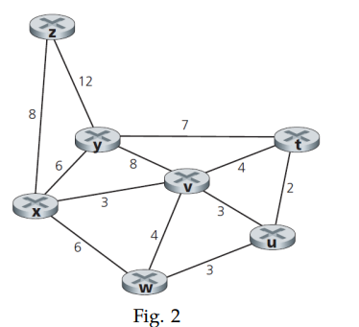

1. Consider the TCP timeout calculation procedure for estimating RTT using EWMA. Suppose that α = 0.1. Let SampleRT T1 be the most recent sample RTT, let SampleRT T2 be the next most recent sample RTT, and so on. Now, answer the following questions with proper explanations. For a given TCP connection, suppose four acknowledgments have been returned with corresponding sample RTTs: SampleRT T4, SampleRT T3, SampleRT T2, and SampleRT T1. Express EstimatedRTT in terms of the four sample RTTs.
2. Suppose, we have connected to a proxy server for the first time. Now only 40% client requests are going through it while the majority of the requests are passing to the origin server or real Internet. Does installing this particular proxy server help us? When do you think it will be useful? Analyze using an example scenario.
3. Suppose Host A sends two TCP segments back to back to Host B over a TCP connection. The first segment has sequence number 3390; the second has sequence number 3450. Now, analyze the following answers with suitable diagrams.

i) Calculate the amount of data sent in the first segment.

ii) Suppose the second segment arrives before the first segment, calculate the acknowledgment number of the second segment.